LAB SKILL 4
NAME: LEE XUAN HUI
MATRIC NO.: A24DW0423

INSTRUCTIONS
You are required to write a C++ program that processes the grades of N students in a class. The program should perform the following tasks:
Part 1: Input Student Grades
- Write a function inputGrades that takes an array and its size as parameters. This function should prompt the user to input grades for all students and store them in the array.
void inputGrades(int grades[], int size);
Part 2: Calculate the Average Grade
- Write a function calculateAverage that takes an array and its size as parameters. This function should return the average of the grades.
double calculateAverage(int grades[], int size);
Part 3: Count the Number of Passing Students
- Write a function countPassingStudents that takes an array, its size, and a passing grade as parameters. This function should return the number of students whose grades are equal to or greater than the passing grade.
int countPassingStudents(int grades[], int size, int passingGrade);
Part 4: Find the Highest Grade
- Write a function findHighestGrade that takes an array and its size as parameters. This function should return the highest grade in the class.
int findHighestGrade(int grades[], int size);
Part 5: Display Results
- Write a main function that uses the functions above to:
  - Declare an array to store the grades.
  - Call inputGrades to fill the array with grades.
  - Call calculateAverage and display the average grade.
  - Call countPassingStudents with a passing grade of 60 and display the number of students who passed.
  - Call findHighestGrade and display the highest grade.

Example Output:
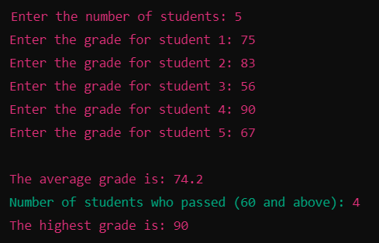

Submission Requirements:
- Your code should be well-documented with comments explaining the purpose of each function and important code blocks.
- Submit the .cpp file containing your program.
- Ensure your program is free of errors and runs successfully before submission.
